# **Name: Abdurrahman Qureshi**

# **Roll No: 210451**

Practical No: 13

**1) Write a Program to display the circular Progress Bar.**

**XML CODE:**

<?xml version="1.0" encoding="utf-8"?>  
<LinearLayout xmlns:android="http://schemas.android.com/apk/res/android"  
 xmlns:app="http://schemas.android.com/apk/res-auto"  
 xmlns:tools="http://schemas.android.com/tools"  
 android:layout_width="match_parent"  
 android:layout_height="match_parent"  
 android:gravity="center"  
 android:padding="5dp"  
 tools:context=".MainActivity">  
 <ProgressBar  
 android:layout_width="200dp"  
 android:layout_height="200dp"  
 style="@style/Widget.AppCompat.ProgressBar"/>  
</LinearLayout>

**JAVA CODE:**

(Java code not required)

**OUTPUT:**

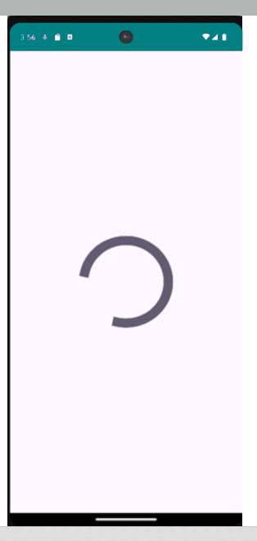

**2) Write a Program to display the following Output.**

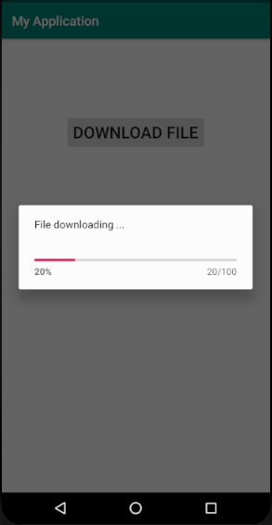

**XML CODE:**

**activity_main.xml:**

<?xml version="1.0" encoding="utf-8"?>  
<LinearLayout xmlns:android="http://schemas.android.com/apk/res/android" xmlns:app="http://schemas.android.com/apk/res-auto"  
xmlns:tools="http://schemas.android.com/tools"  
 android:layout_width="match_parent"  
 android:layout_height="match_parent"  
 android:padding="5dp"  
 android:orientation="vertical"  
 tools:context=".MainActivity">  
 <Button  
 android:id="@+id/file_btn"  
 android:layout_width="wrap_content"  
 android:layout_height="wrap_content"  
 android:text="Download File"  
 android:layout_gravity="center"  
 android:layout_marginTop="100dp"  
 android:textSize="20sp"/>  
 <LinearLayout  
 android:layout_width="wrap_content"  
 android:layout_height="wrap_content"  
 android:gravity="center"  
 android:layout_gravity="center"  
 android:layout_marginTop="100dp">  
 <include  
 layout="@layout/progressbar_layout"  
android:id="@+id/progress_bar_layout"  
 android:visibility="gone"/>  
 </LinearLayout>  
</LinearLayout>

**progressbar_layout.xml:**

<?xml version="1.0" encoding="utf-8"?>  
<LinearLayout xmlns:android="http://schemas.android.com/apk/res/android"  
 android:layout_width="300dp"  
 android:layout_height="100dp"  
 android:padding="10dp"  
 android:id="@+id/progress_bar_layout"  
 android:orientation="vertical">  
 <TextView  
 android:id="@+id/file_text"  
 android:layout_width="wrap_content"  
 android:layout_height="wrap_content"  
 android:textSize="15sp"  
 android:text="File downloading"/>  
 <ProgressBar  
 android:id="@+id/progress_bar"  
 android:layout_width="280dp"  
 android:layout_height="10dp"  
 android:layout_gravity="center"  
style="@style/Widget.AppCompat.ProgressBar.Horizontal"  
 android:layout_marginTop="40dp"/>  
</LinearLayout>

**JAVA CODE:**

package com.example.madprac13;  
  
import androidx.appcompat.app.AppCompatActivity;  
  
import android.app.ProgressDialog;  
import android.os.Bundle;  
import android.os.Handler;  
import android.view.View;  
import android.widget.Button;  
import android.widget.LinearLayout;  
import android.widget.TextView;  
  
public class MainActivity extends AppCompatActivity {  
  
 Button btnStartProgress;  
 ProgressDialog progressDialog;  
 private int progressBarStatus = 0;  
 private Handler progressBarHandler = new Handler();  
 private long fileSize = 0;  
 @Override  
 protected void onCreate(Bundle savedInstanceState) {  
 super.onCreate(savedInstanceState);  
 setContentView(R.layout.activity_main);  
 addListenerOnButtonClick();  
 }  
 public void addListenerOnButtonClick() {  
 btnStartProgress = (Button) findViewById(R.id.file_btn);  
 btnStartProgress.setOnClickListener(new View.OnClickListener() {  
 @Override  
 public void onClick(View view) {  
 progressDialog = new ProgressDialog(view.getContext());  
 progressDialog.setCancelable(true);  
 progressDialog.setMessage("File downloading...");  
 progressDialog.setProgressStyle(ProgressDialog.STYLE_HORIZONTAL);  
 progressDialog.setProgress(0);  
 progressDialog.setMax(100);  
 progressDialog.show();  
 progressBarStatus = 0;  
 fileSize = 0;  
 new Thread(new Runnable() {  
 @Override  
 public void run() {  
 while (progressBarStatus < 100) {  
 progressBarStatus = doOperation();  
 try {  
 Thread.sleep(1200);  
 } catch (InterruptedException e) {  
 e.printStackTrace();  
 }  
 progressBarHandler.post(new Runnable() {  
 @Override  
 public void run() {  
 progressDialog.setProgress(progressBarStatus);  
 }  
 });  
 }  
 if (progressBarStatus >= 100) {  
 try {  
 Thread.sleep(1200);  
 } catch (InterruptedException e) {  
 e.printStackTrace();  
 }  
 progressDialog.dismiss();  
 }  
 }  
 }).start();  
 }  
 });  
 }  
 public int doOperation() {  
 while (fileSize <= 10000) {  
 fileSize++;  
 return (int)(fileSize / 100);  
 }  
 return 100;  
 }  
}

**OUTPUT:**

